Cornel Stoica  
CST238

Peer Review #2  
for Adam Fanelli

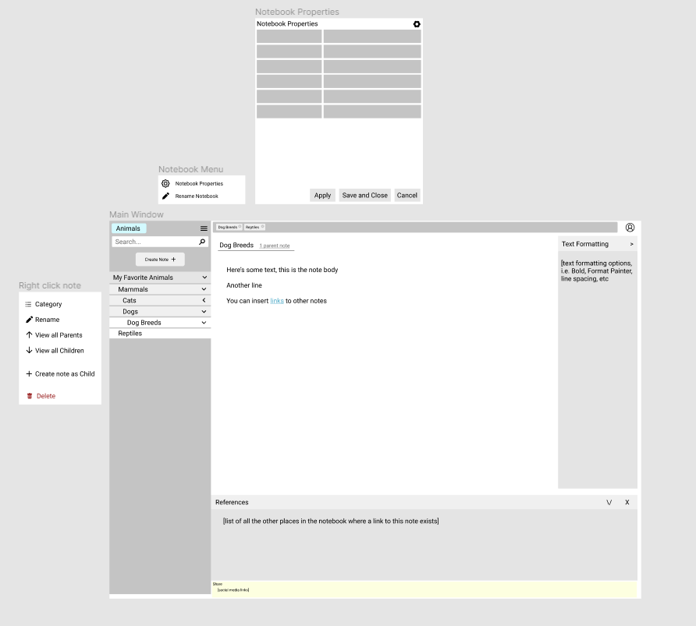

Suggestions:

* Increasing font/size/x button for tabs above pages would help ease navigation
* Adding more color to window overall would help decrease grayscale
* Consider adding thin borders around inside panels (formatting, references, left panel)